Database Tables-

1. Registration Table

Table’s Name- wedding_regdb

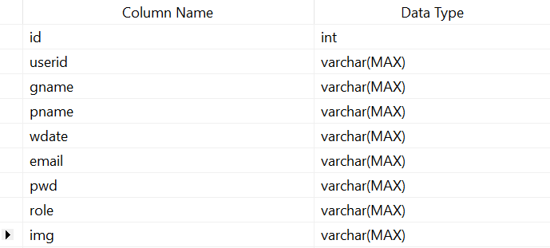

1. Otp Table

Table’s Name- wedding_otpcheck

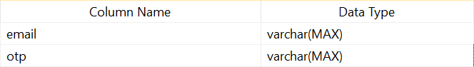

1. Guest Table

Table’s Name- guestlist_wedding

